Experiment No: 3

Experiment Name: Cracking the Password Using Hydra

Aim
To understand and demonstrate password auditing using Hydra against an authorized test system and identify weak login credentials.

Procedure
- Open Kali Linux and launch the Terminal.
- Verify that Hydra is installed:
- hydra -h
- Start the vulnerable/test machine and identify its IP address.
- Prepare a username and password wordlist for the lab.
- Select the login service to be tested, such as FTP, on the authorized lab machine.
- a tests the passwords from the wordlist against the specified account.
- Observe the terminal output and record the result.
- Stop the scan after the authorized lab test is completed.

Output
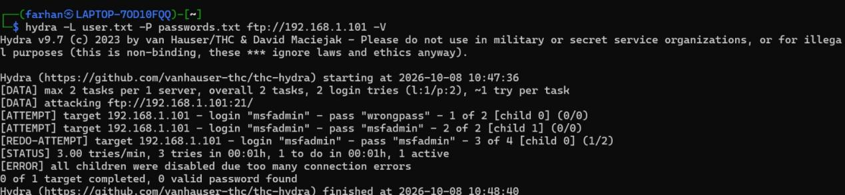

Result
Thus, password auditing was successfully performed using Hydra on the authorized test system, and the weak password was identified from the provided wordlist.

